## Alert SP2 linear calibrations for extrapolation outside of calibration range:

**SP2#17:**

* 4-channel HG only
* Saturation limit = 3600
* 5-March-2011 TO 24-March 2012
* Sample rate was 1/1 always, but data was written 1 of every 10 minutes from 20110301 on

Linear calib:

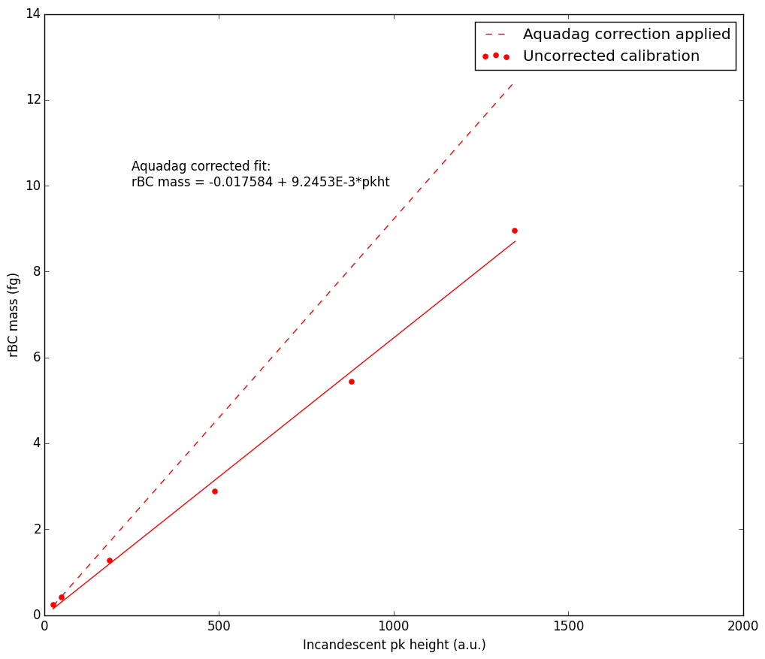

**SP2#44**

* 8-channel, keep 2nd order polynomial calib for HG channel but use linear (below) and extrapolate for LG channel
* Saturation limit = 60,000
* 27-March-2012 TO 22-Sept-2013
* Sample rate 1/8 – always

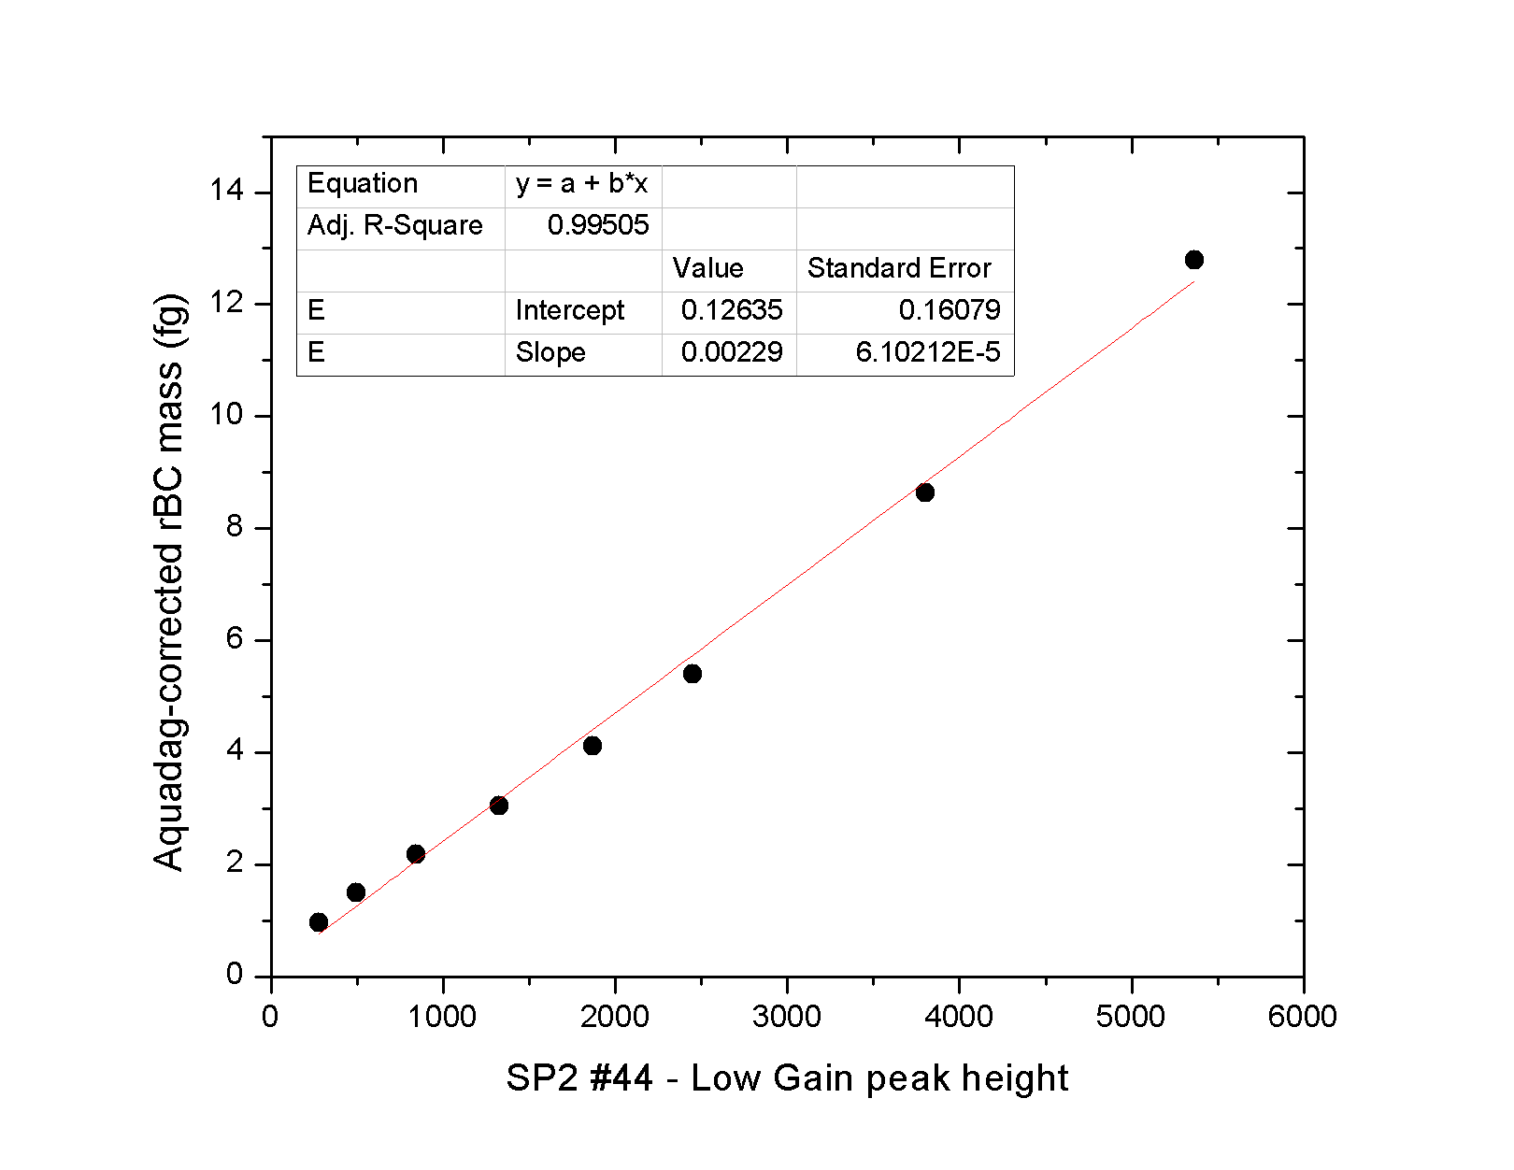

**SP2#58**

* 8-channel, keep 2nd order polynomial calib for HG channel but use linear (below) and extrapolate for LG channel
* Saturation limit = 60,000
* 27-Sept-2013 TO Current
* Sample rate 1/10 – always

